#Question no 1

def minNum(a):

mini=(a[0])

for i in a :

if i < mini:

mini=i

return mini

a=[1,9,2,5,7,5]

print(minNum(a))

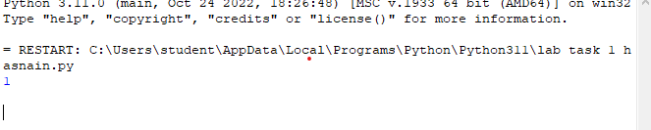

# QUESTION NO 2

def squarelist(a):

y=[]

for i in range (0,len(a)):

y.append(a[i]**2)

return y

a=[2,2,4,6,9]

print(squarelist(a))

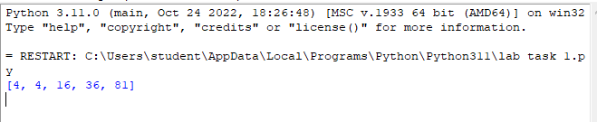

#QUESTION NO 3

def reverse (s):

y=[]

for x in range (len(s)-1,-1,-1):

y.append(s[x])

return y

s=[1,2,3,5]

print (reverse(s))

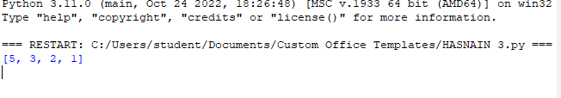

#QUESTION NO 4

def Sort(l):

n = len(l)

swapped = False

for i in range(n-1):

for j in range(0, n-i-1):

if l[j] > l[j + 1]:

swapped = True

l[j], l[j + 1] = l[j + 1], l[j]

if not swapped:

return

l = [61, 84, 5, 90, 22, 67, 30]

Sort(l)

print(l)

